**5 - Create Child Work Order**

This process is to create a Child Work Order that is linked to the original Work order which will allow you to create Individual or only one Invoice. This works when you have the same Work Order Group, and a combination of different Work Order Groups. There are 5 Different combinations listed in the document please read and follow instructions as they behave differently. When you have a technician that is working on another branches work order you will need to create the child and select consolidate for Invoice so that the customer only gets one invoice. If you want to consolidate the Invoice then you need to do the setup at the Creation the Work order each time before transactions are applied. There is no function to set this once the work order has been created. With Different Work Order groups you wont need to select yes to consolidate for Invoicing but will be able to Invoice each Child. You will **NOT** create a child work order for the following Work order Group – **CON INT, CON EXT, CON FMOL and CON RENTAL**.

1. **The following process is for when you have the same Work Order Group**
2. Go to Work order management > Work Orders > Work Orders.
3. You need to filter either on main filter or columns to get the required Work Order to add The Child to.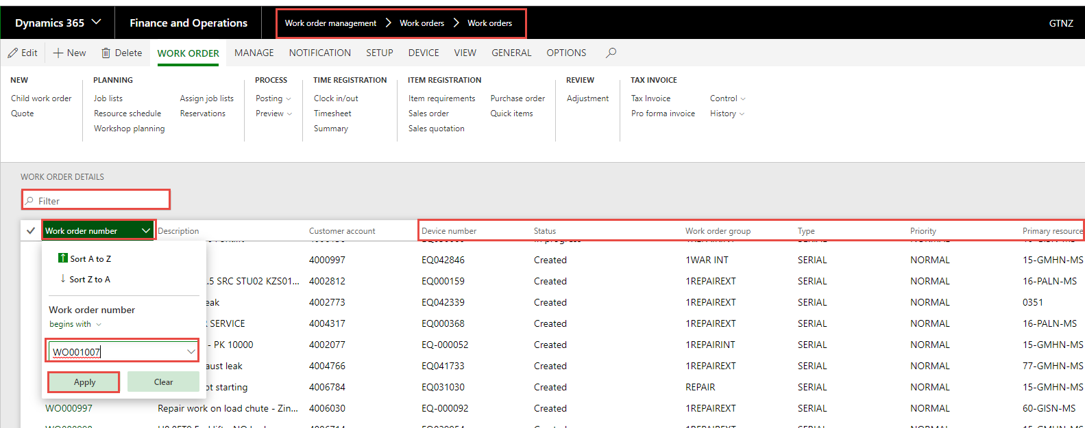
4. You will now select – Child Work Order.  
   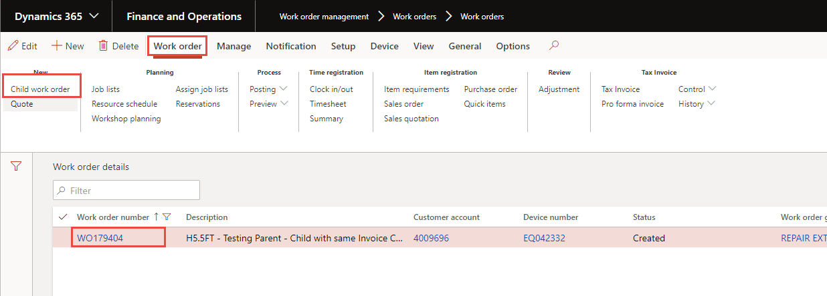
5. You get the Popup Box – Transfer Customer Information - Select Yes.  
   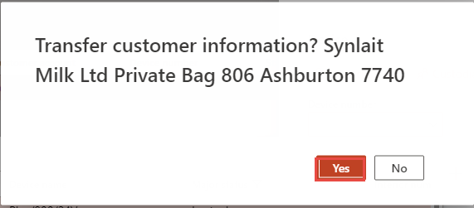
6. Device Number – this comes us so that you can select the correct device for the Child Work order – could be the same as Parent or different. Filter on All Devices.  
   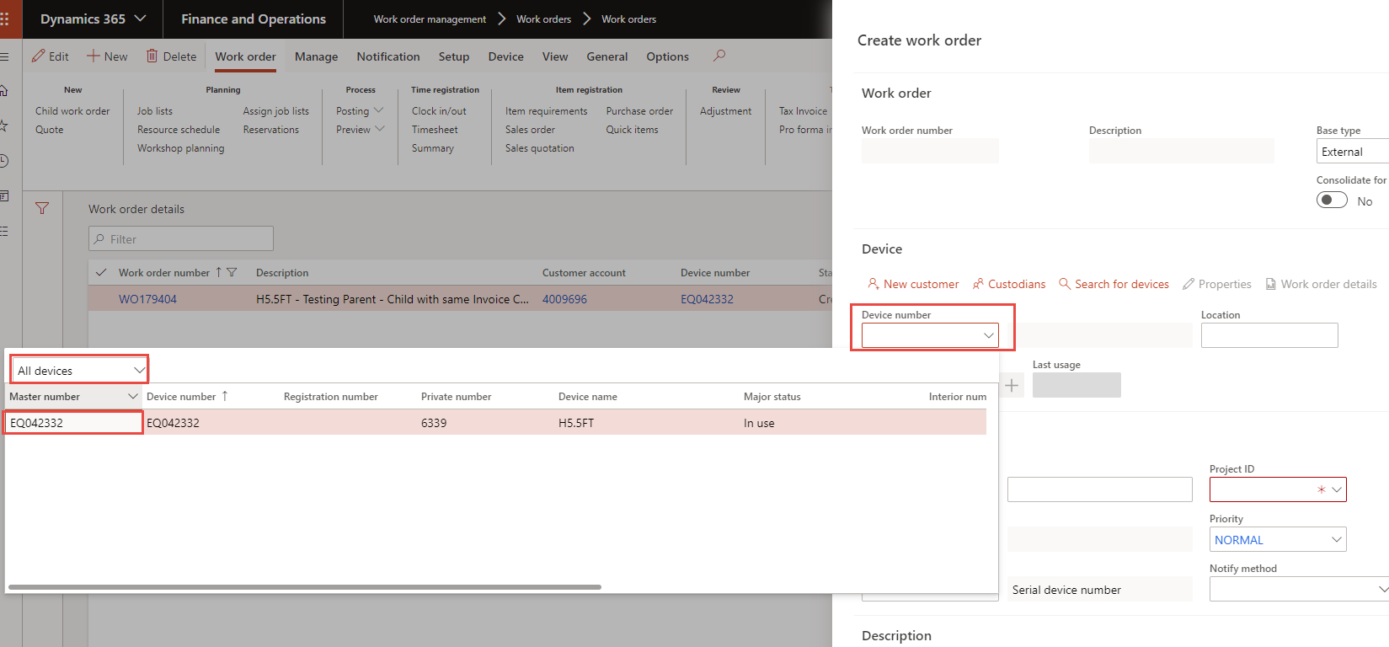
7. Work Order Device Validation may appears you select Cancel or OK.  
   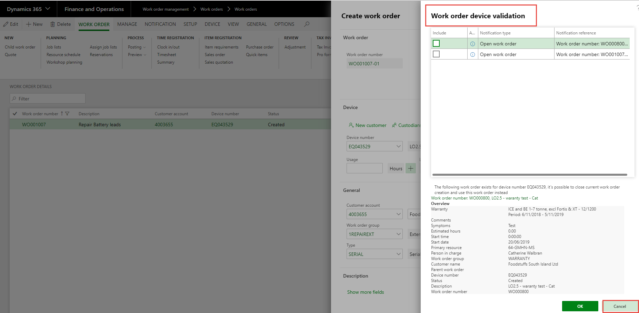
8. If you are consolidating the Invoices you need to select Yes - Consolidate for Invoice.  
   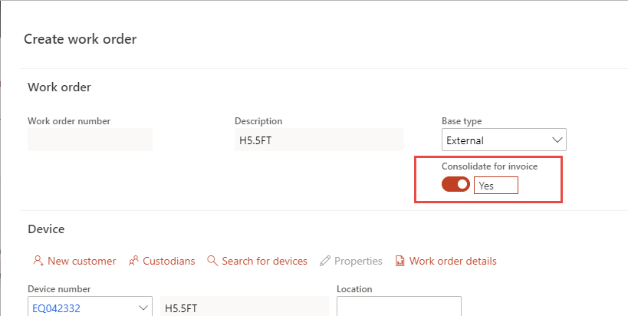
9. In the Usage field, enter a Current usage if you have it. Click on the +. Usage registration appears make sure that you populate the correct usage date - you select OK.  
   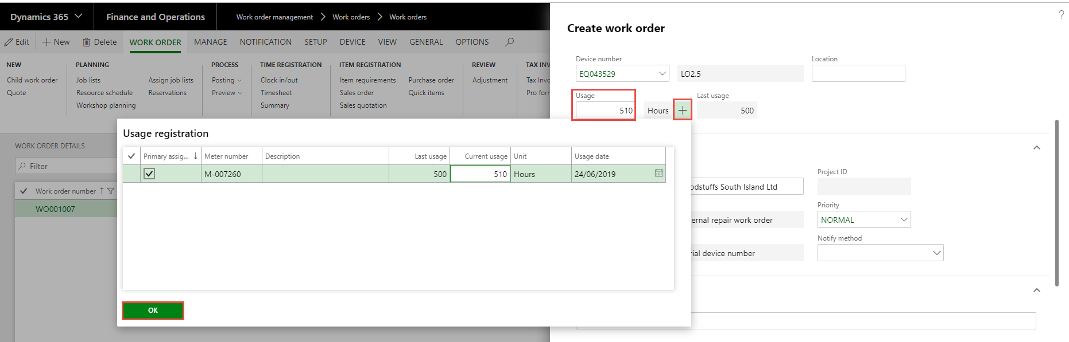
10. Work Order Group – need to Select from the Drop-down list. – OK.  
    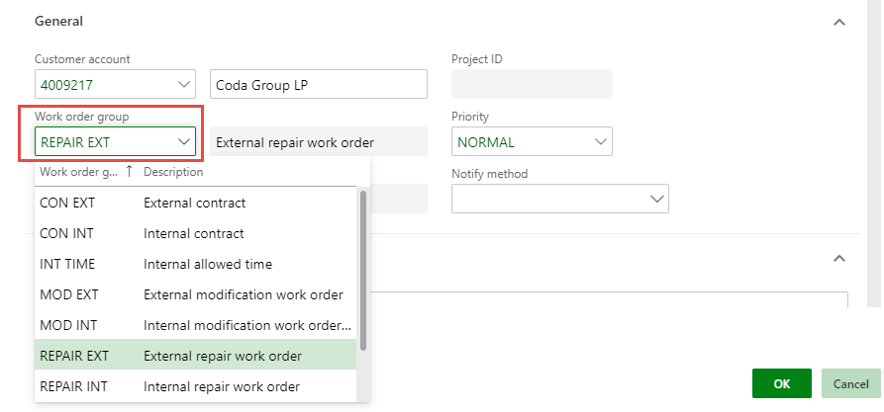
11. If this is for an Internal Work Order Group (WAR INT, REPAIR INT) Please change the customer here, using the drop down to filter and select the correct account.  
    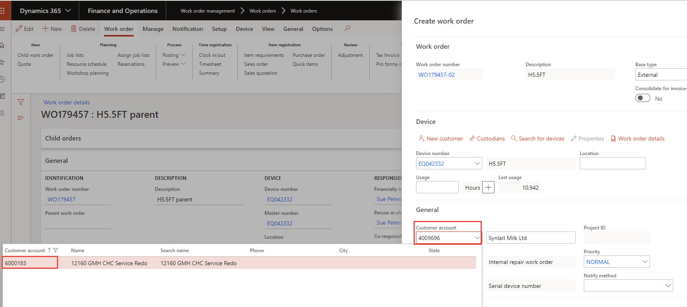
12. You get the following message – transfer customer Infor – Select No.  
    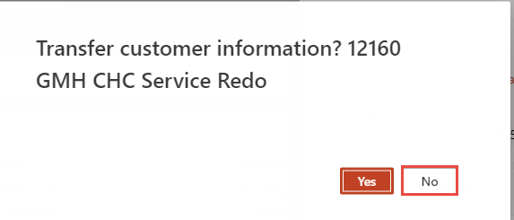
13. Description – Brief description of work.
14. Details – Symptoms – More detailed description of work.  
    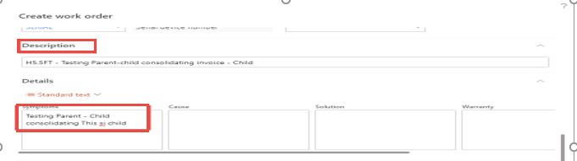
15. Under Schedule Tab you Populate the Primary Resource Group.
16. Start Date - Start Date Is the day the work started – parts ordered. Please be accurate and use the drop-down box to select the correct start date.
17. Also select – Show More Fields.  
    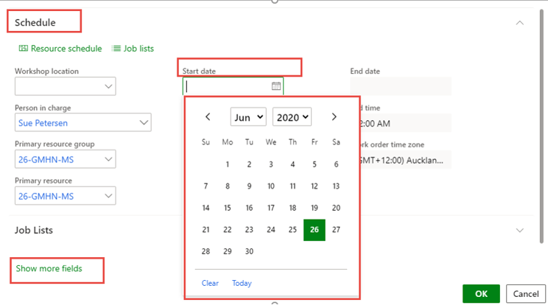
18. Check that you have the correct Invoice customer, if not change. For REPAIR INT & WAR INT Work order Groups you should see the internal account populated.  
    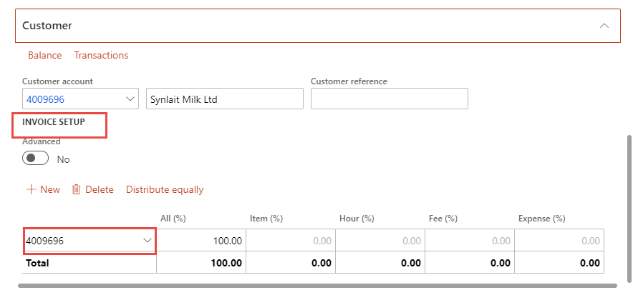  
    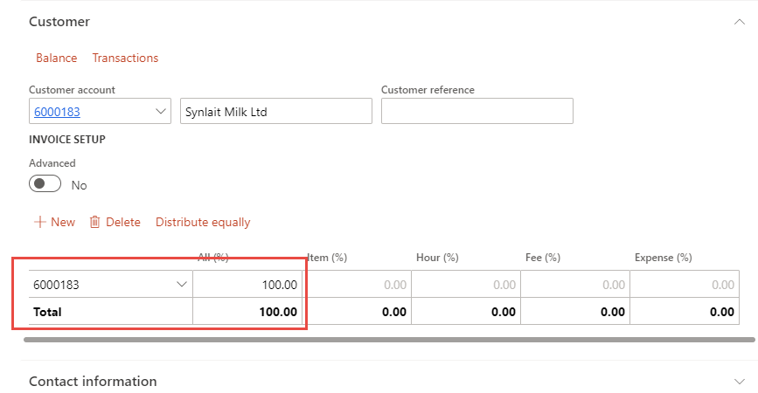
19. Change invoice customer – select new, use filter to find correct customer.  
    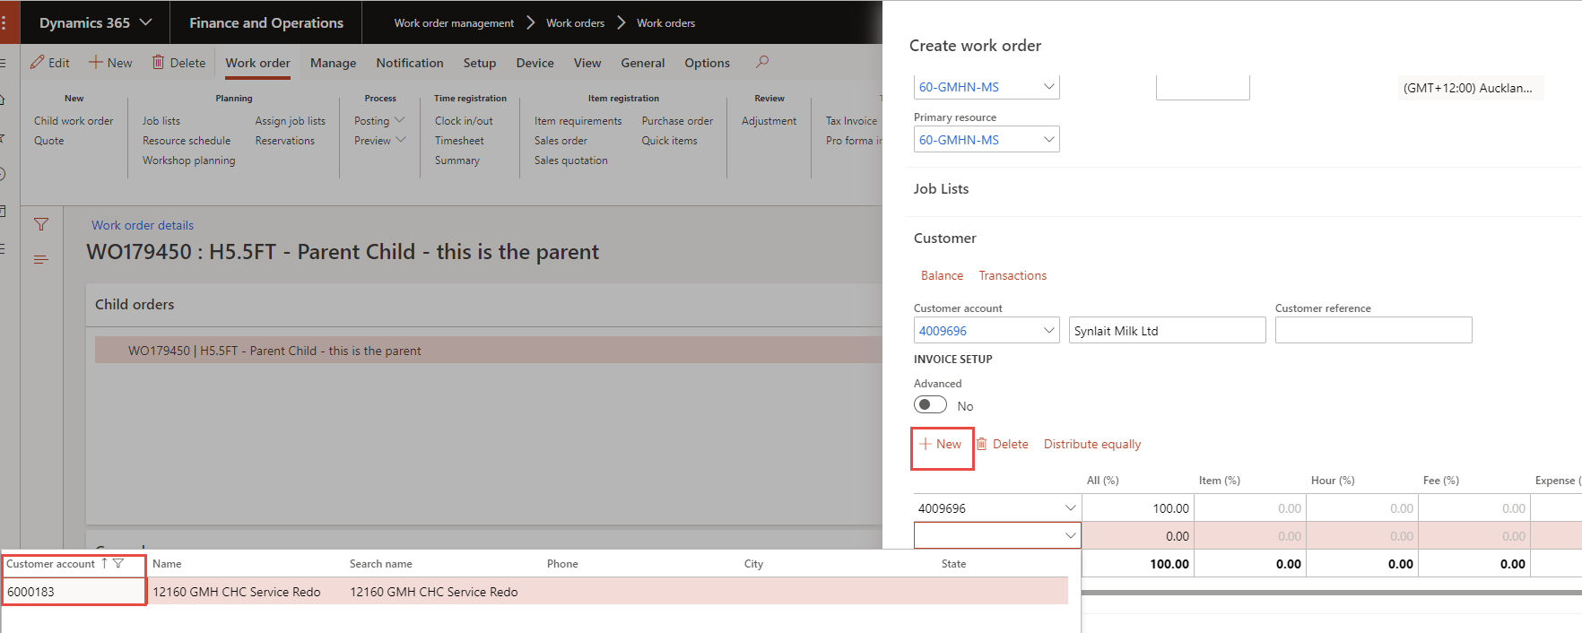
20. You get popup message – transfer customer information – Select No.  
    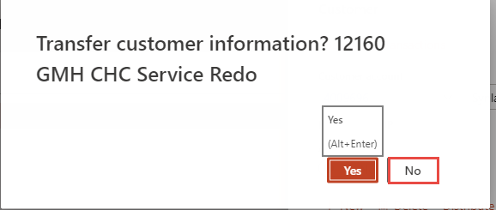
21. Change the All% from the original account to the new account.  
    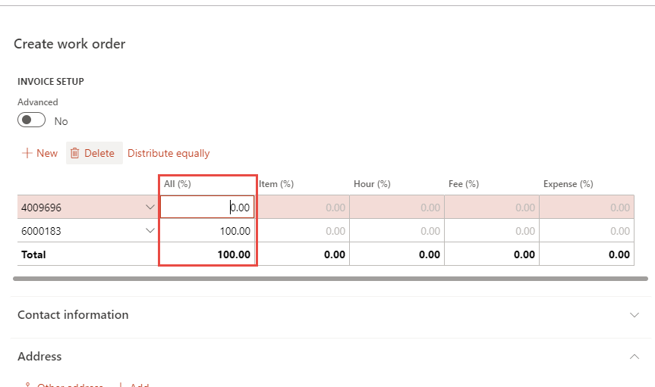
22. Check that we have the correct Address – Custodians.
23. Check the Financial Dimension.
24. Select OK.  
    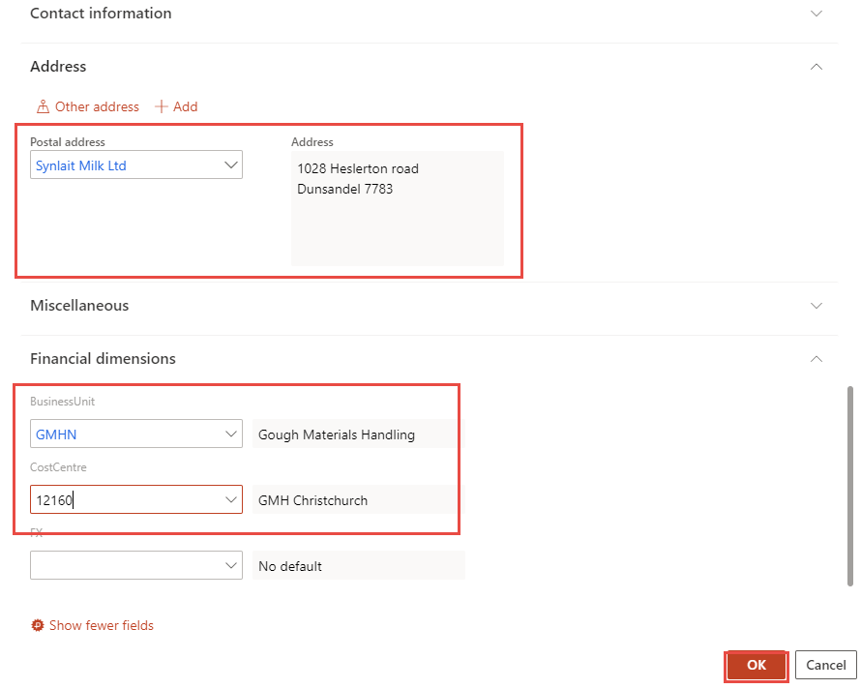
25. Once you have completed the creation of the Work order You can see your Work Order and Child by following the filter below.  
    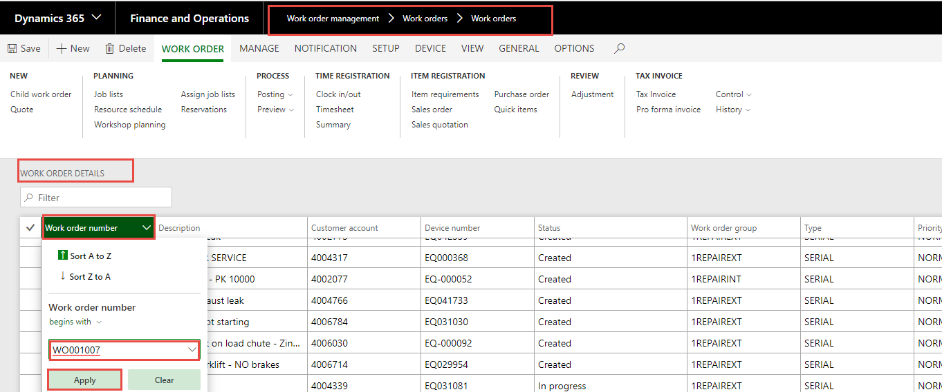
26. Below you see the Work order and the child -01.  
    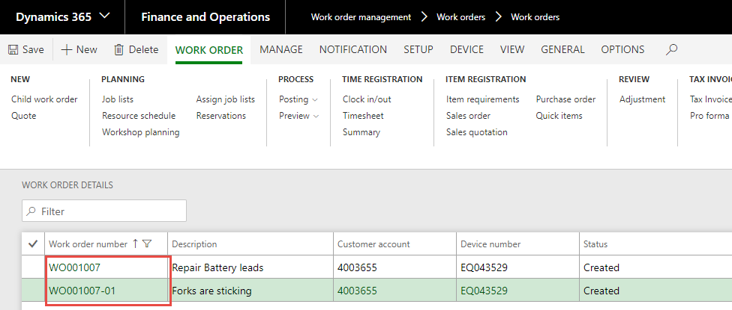
27. Please check that the Work has the correct GST Setting. Open the Work Order > Customer Tab. Click on the Project ID.  
    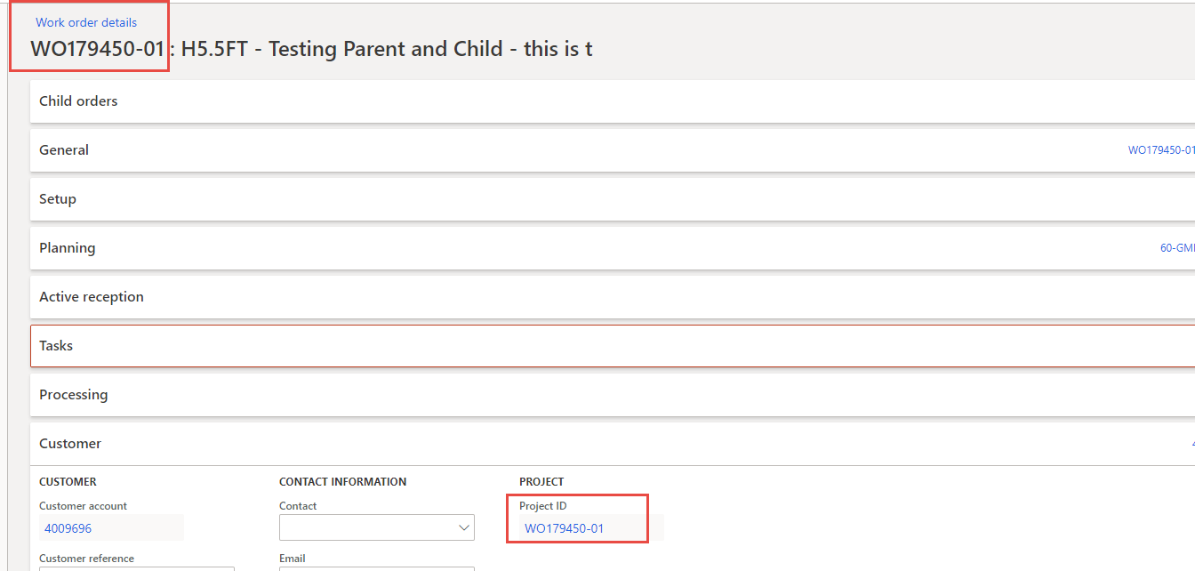
28. This takes you to the Project. On the Setup Tab – GST Group you need to confirm it is correct and if not – edit and change and then save.  
    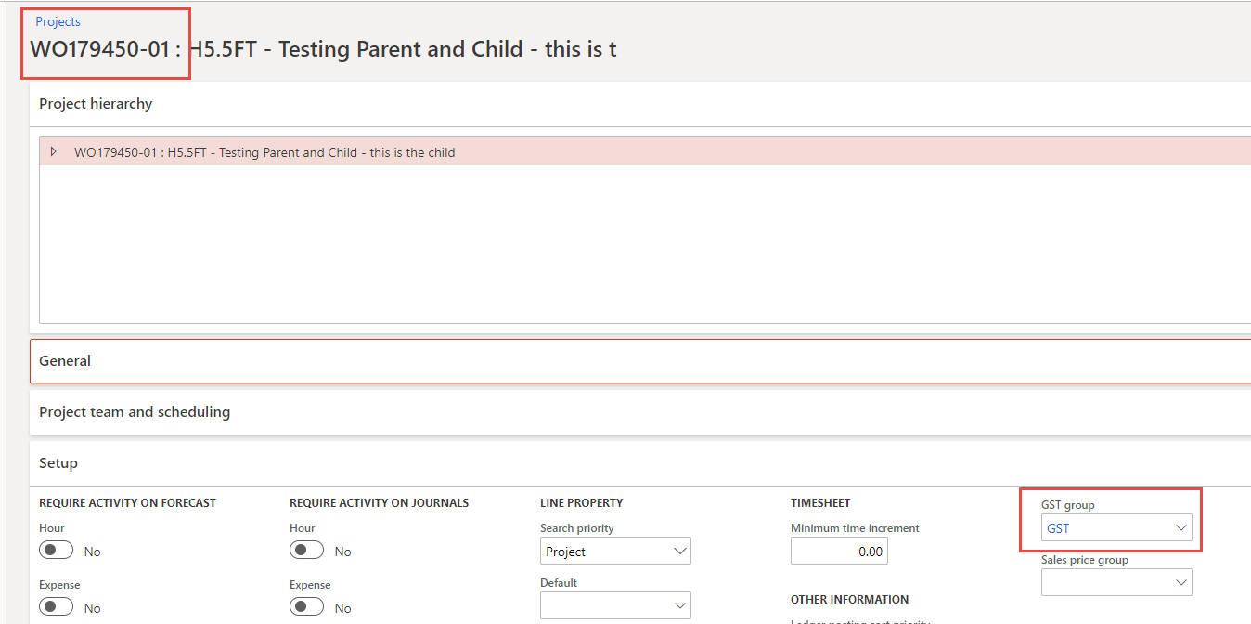
29. Close.
30. Close.
31. You can also see the link to the parent work order from the Child.  
    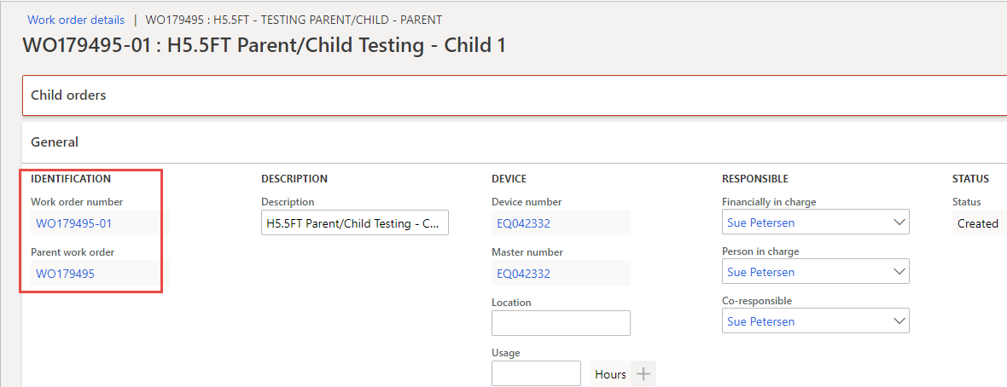
32. If you have the start date incorrect you can amend later by selecting the Planning TAB.  
    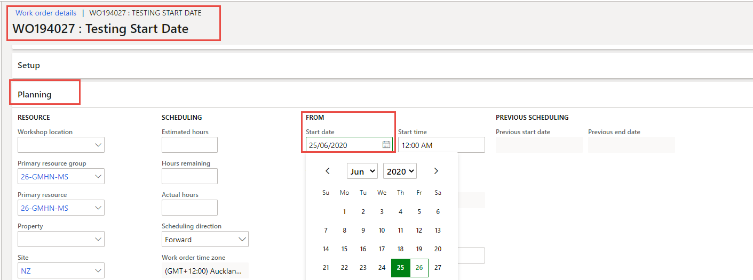
33. You now follow the same process as you would for populating all the requried charges to the Work Order.
34. **The following process is for when you have Different Work Order Groups – Parent REPAIR EXT – Child REPAIR INT, WAR INT & WAR EXT**
35. Go to Work order management > Work Orders > Work Orders.
36. You need to filter either on main filter or columns to get the required Work Order to add The Child to.
37. You will now select – Child Work Order.  
    
38. You get the Popup Box – Transfer Customer Information - Select Yes.  
    
39. Device Number – this comes us so that you can select the correct device for the Child Work order – should be the same as Parent. Filter on All Devices.  
    
40. Work Order Device Validation may appears you select Cancel or OK.  
    
41. You will not be consolidating the Invoices as you have the Different Invoice Customers – Select NO.  
    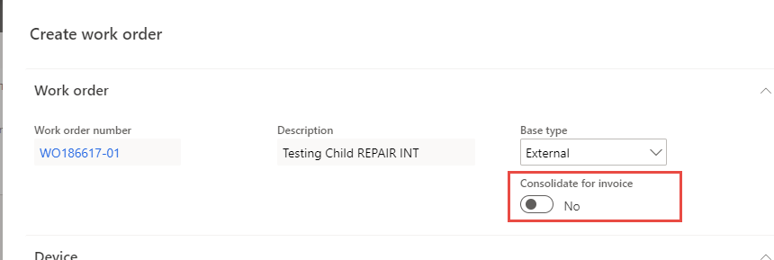
42. In the Usage field, enter a Current usage if you have it. Click on the +. Usage registration appears make sure that you populate the correct usage date - you select OK.  
    
43. Work Order Group – need to Select from the Drop-down list. – OK.  
    
44. If this is for an Internal Work Order Group (WAR INT, REPAIR INT) Please change the customer here, using the drop down to filter and select the correct account.  
    
45. You get the following message – transfer customer Infor – Select No.  
    
46. Description – Brief description of work.
47. Details – Symptoms – More detailed description of work.  
    
48. Under Schedule Tab you Populate the Primary Resource Group.
49. Start Date - Start Date Is the day the work started – parts ordered. Please be accurate and use the drop-down box to select the correct start date.
50. Also select – Show More Fields.  
    
51. You will see that you have the Customer Account number (internal Account) but the name is the Customer. The invoice account is still set to customer. You will need to change this for REPAIR INT, WAR INT & WAR EXT Work order Groups.  
      
    
52. Change invoice customer – select new, use filter to find correct customer.  
    
53. You get popup message – transfer customer information – Select No.  
    
54. Change the All% from the original account to the new account.  
    
55. Check that we have the correct Address – Custodians.
56. Check the Financial Dimension.
57. Select OK.  
    
58. Once you have completed the creation of the Work order You can see your Work Order and Child by following the filter below.  
    
59. Below you see the Work order and the child -01.  
    
60. Please check that the Work has the correct GST Setting. Open the Work Order > Customer Tab. Click on the Project ID.  
    
61. This takes you to the Project. On the Setup Tab – GST Group you need to confirm it is correct and if not – edit and change and then save.  
    
62. Close.
63. Close.
64. You can also see the link to the parent work order from the Child.  
    
65. If you have the start date incorrect you can amend later. Planning TAB  
    
66. You now follow the same process as you would for populating all the requried charges to the Work Order.
    1. **The following process is for when you have Different Work Order Groups – Parent WAR EXT – Child REPAIR INT, WAR INT & REPAIR EXT**
67. Go to Work order management > Work Orders > Work Orders.
68. You need to filter either on main filter or columns to get the required Work Order to add The Child to.
69. You will now select – Child Work Order.  
    
70. You get the Popup Box – Transfer Customer Information - Select Yes.  
    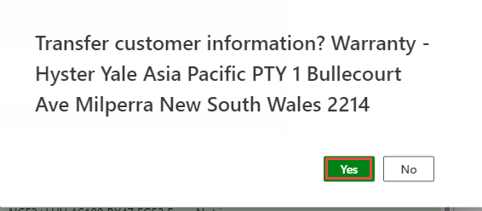
71. Device Number – this comes us so that you can select the correct device for the Child Work order – should be the same as Parent. Filter on All Devices.  
    
72. Work Order Device Validation may appears you select Cancel or OK.  
    
73. You will not be consolidating the Invoices as you have the Different Invoice Customers – Select NO.  
    
74. In the Usage field, enter a Current usage if you have it. Click on the +. Usage registration appears make sure that you populate the correct usage date - you select OK.  
    
75. Work Order Group – need to Select from the Drop-down list. – OK.  
    
76. If this is for an Internal Work Order Group (WAR INT, REPAIR INT) Please change the customer here, using the drop down to filter and select the correct account.  
    
77. You get the following message – transfer customer Infor – Select No.  
    
78. Description – Brief description of work.
79. Details – Symptoms – More detailed description of work.  
    
80. Under Schedule Tab you Populate the Primary Resource Group.
81. Start Date - Start Date Is the day the work started – parts ordered. Please be accurate and use the drop-down box to select the correct start date.
82. Also select – Show More Fields.  
    
83. You will see that you have the Customer Account number (internal Account) but the name is the Customer. The invoice account is still set to customer. You will need to change this for REPAIR INT, WAR INT, REPAIR EXT Work order Groups.  
    
84. Change invoice customer – select new, use filter to find correct customer.  
    
85. You get popup message – transfer customer information – Select No.  
    
86. Change the All% from the original account to the new account.  
    
87. Check that we have the correct Address – Custodians.
88. Check the Financial Dimension.
89. Select OK.  
    
90. Once you have completed the creation of the Work order You can see your Work Order and Child by following the filter below.  
    
91. Below you see the Work order and the child -01.  
    
92. Please check that the Work has the correct GST Setting. Open the Work Order > Customer Tab. Click on the Project ID.  
    
93. This takes you to the Project. On the Setup Tab – GST Group you need to confirm it is correct and if not – edit and change and then save.  
    
94. Close.
95. Close.
96. You can also see the link to the parent work order from the Child.  
    
97. If you have the start date incorrect you can amend later. Plqnning TAB.  
    
98. You now follow the same process as you would for populating all the requried charges to the Work Order.
    1. **The following process is for when you have Different Work Order Groups – Parent REPAIR INT – Child WAR INT, WAR EXT & REPAIR EXT**
99. Go to Work order management > Work Orders > Work Orders.
100. You need to filter either on main filter or columns to get the required Work Order to add The Child to.
101. You will now select – Child Work Order.  
     
102. You get the Popup Box – Transfer Customer Information - Select Yes.  
     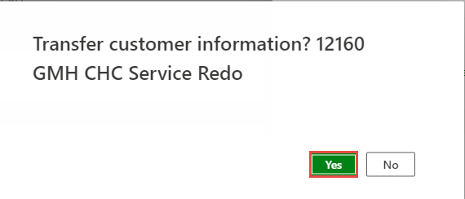
103. Device Number – this comes us so that you can select the correct device for the Child Work order – should be the same as Parent. Filter on All Devices.  
     
104. Work Order Device Validation may appears you select Cancel or OK.  
     
105. You will not be consolidating the Invoices as you have the Different Invoice Customers – Select NO.  
     
106. In the Usage field, enter a Current usage if you have it. Click on the +. Usage registration appears make sure that you populate the correct usage date - you select OK.  
     
107. Work Order Group – need to Select from the Drop-down list. – OK.  
     
108. If this is for an Internal Work Order Group (WAR INT) or WAR EXT. Please change the customer here, using the drop down to filter and select the correct account.   
     
109. You get the following message – transfer customer Infor – Select No.  
     
110. When Work order group is WAR EXT you get this popup box – Select NO  
     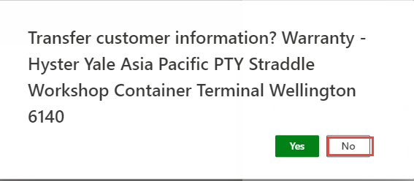
111. Description – Brief description of work.
112. Details – Symptoms – More detailed description of work.  
     
113. Under Schedule Tab you Populate the Primary Resource Group.
114. Start Date - Start Date Is the day the work started – parts ordered. Please be accurate and use the drop-down box to select the correct start date.
115. Also select – Show More Fields.  
     
116. You will see that you have the Customer Account number (internal Account) but the name is the Customer. The invoice account is still set to customer. You will need to change this for WAR EXT, WAR INT, REPAIR EXT Work order Groups.



1. Change invoice customer – select new, use filter to find correct customer.  
   
2. You get popup message – transfer customer information – Select No.  
   
3. Change the All% from the original account to the new account.  
   
4. Check that we have the correct Address – Custodians.
5. Check the Financial Dimension.
6. Select OK.  
   
7. Once you have completed the creation of the Work order You can see your Work Order and Child by following the filter below.  
   
8. Below you see the Work order and the child -01.  
   
9. Please check that the Work has the correct GST Setting. Open the Work Order > Customer Tab. Click on the Project ID.  
   
10. This takes you to the Project. On the Setup Tab – GST Group you need to confirm it is correct and if not – edit and change and then save.  
    
11. Close.
12. Close.
13. You can also see the link to the parent work order from the Child.  
    
14. If you have the start date incorrect you can amend it. Planning TAB.  
    
15. You now follow the same process as you would for populating all the requried charges to the Work Order.
    1. **The following process is for when you have Different Work Order Groups – Parent WAR INT – Child WAR EXT, REPAIR EXT & REPAIR INT**
16. Go to Work order management > Work Orders > Work Orders.
17. You need to filter either on main filter or columns to get the required Work Order to add The Child to.
18. You will now select – Child Work Order.  
    
19. You get the Popup Box – Transfer Customer Information - Select Yes.  
    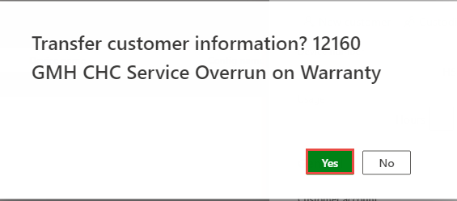
20. Device Number – this comes us so that you can select the correct device for the Child Work order – should be the same as Parent. Filter on All Devices.  
    
21. Work Order Device Validation may appears you select Cancel or OK.  
    
22. You will not be consolidating the Invoices as you have the Different Invoice Customers – Select NO.  
    
23. In the Usage field, enter a Current usage if you have it. Click on the +. Usage registration appears make sure that you populate the correct usage date - you select OK.  
    
24. Work Order Group – need to Select from the Drop-down list. – OK.  
    
25. If this is for an Internal Work Order Group (REPAIR INT) or WAR EXT. Please change the customer here, using the drop down to filter and select the correct account.   
    
26. You get the following message – transfer customer Infor – Select No.  
    
27. When Work order group is WAR EXT you get this popup box – Select NO  
    
28. Description – Brief description of work.
29. Details – Symptoms – More detailed description of work.  
    
30. Under Schedule Tab you Populate the Primary Resource Group.
31. Start Date - Start Date Is the day the work started – parts ordered. Please be accurate and use the drop-down box to select the correct start date.
32. Also select – Show More Fields.  
    
33. You will see that you have the Customer Account number (internal Account) but the name is the Customer. The invoice account is still set to customer. You will need to change this for WAR EXT, REPAIR EXT Work order Groups.  
      
    
34. Change invoice customer – select new, use filter to find correct customer.  
    
35. You get popup message – transfer customer information – Select No.  
    
36. Change the All% from the original account to the new account.  
    
37. Check that we have the correct Address – Custodians.
38. Check the Financial Dimension.
39. Select OK.  
    
40. Once you have completed the creation of the Work order You can see your Work Order and Child by following the filter below.  
    
41. Below you see the Work order and the child -01.  
    
42. Please check that the Work has the correct GST Setting. Open the Work Order > Customer Tab. Click on the Project ID.  
    
43. This takes you to the Project. On the Setup Tab – GST Group you need to confirm it is correct and if not – edit and change and then save.  
    
44. Close.
45. Close.
46. You can also see the link to the parent work order from the Child.  
    
47. If you have the start date incorrect you can amend it. Planning TAB.  
    
48. You now follow the same process as you would for populating all the requried charges to the Work Order.